Unit Tests

## Test Case 1: Name Entry

The user is able to enter a name that displays on their profile card. They should only be able to enter alphanumeric characters and spaces. The program should also allow the player to use the shift key to enter uppercase letters.

### Test Set 1:

“David”

#### Expected Result:

The program should take the input and display it in the “Name” field.

#### Result:

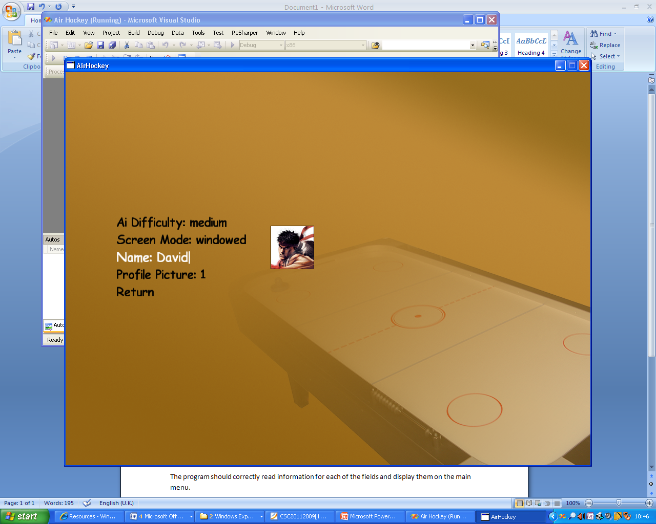

As shown, the program accepts all of the characters as they are entered.

### Test Set 2:

“David 2||”

#### Expected Result:

The program should allow the number and space appended but should reject any non-alphanumeric characters apart from the space character.

#### Result:

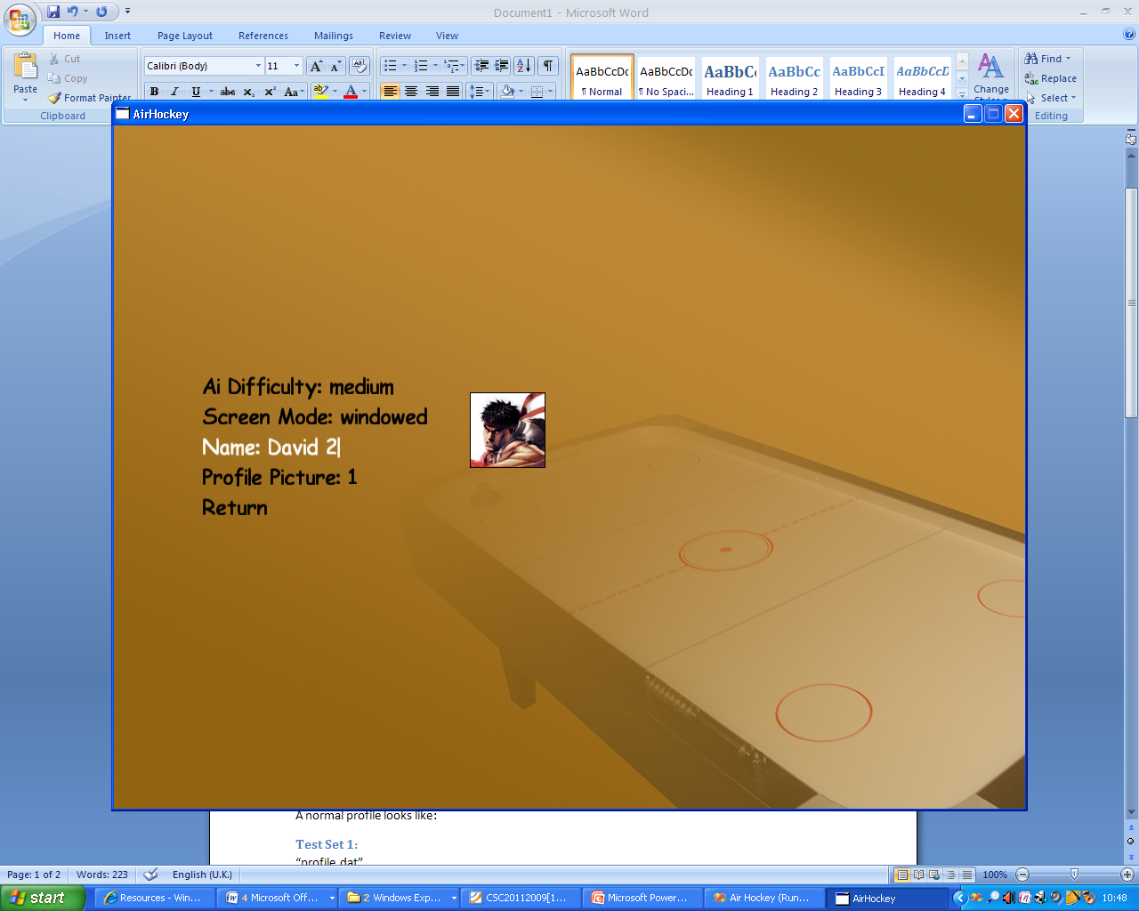

In this case the program accepts the letters and numbers but ignores the pipe characters.

## Test Case 2: Profile Reading

The program writes the user’s profile to file so that it may be read upon program start. The system needs to be able to cope with invalid profiles such as those saved with an earlier version of the program or corrupted files.

A normal profile looks like:

### Test Set 1:

“profile.dat”

*<?xml version="1.0"?>*

*<Profile xmlns:xsi="http://www.w3.org/2001/XMLSchema-instance" xmlns:xsd="http://www.w3.org/2001/XMLSchema">*

*<Name>David</Name>*

*<Win>0</Win>*

*<Lost>0</Lost>*

*<Draw>0</Draw>*

*<PictureIndex>2</PictureIndex>*

*</Profile>*

#### Expected Result:

The program should correctly read information for each of the fields and display them on the main menu.

#### Result:

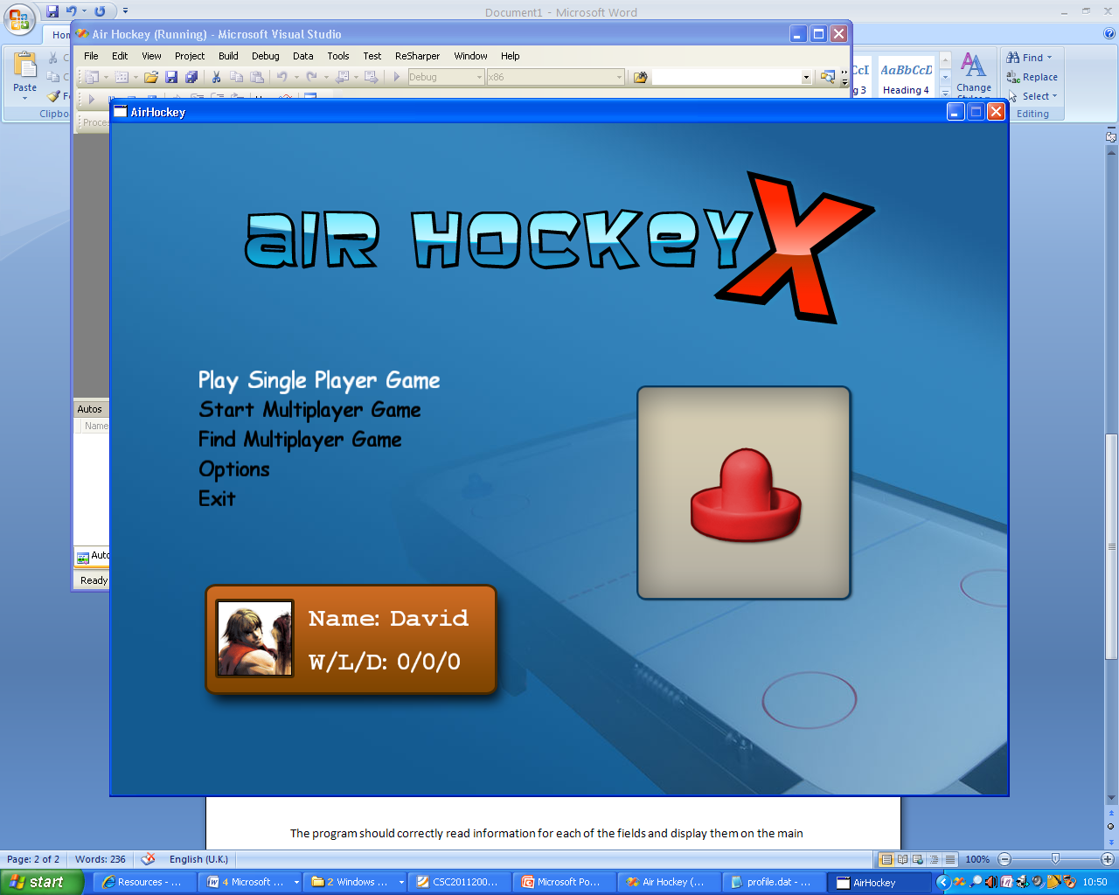

The profile is correctly read in and the fields are populated correctly. The selected player picture is also accurately reflected by the icon.

### Test Set 2:

“profile.dat”

*<?xml version="1.0"?>*

*<Profile xmlns:xsi="http://www.w3.org/2001/XMLSchema-instance" xmlns:xsd="http://www.w3.org/2001/XMLSchema">*

*</Profile>*

#### Expected Result:

The program should continue running despite the invalid file. The profile card should still display valid data rather than null fields.

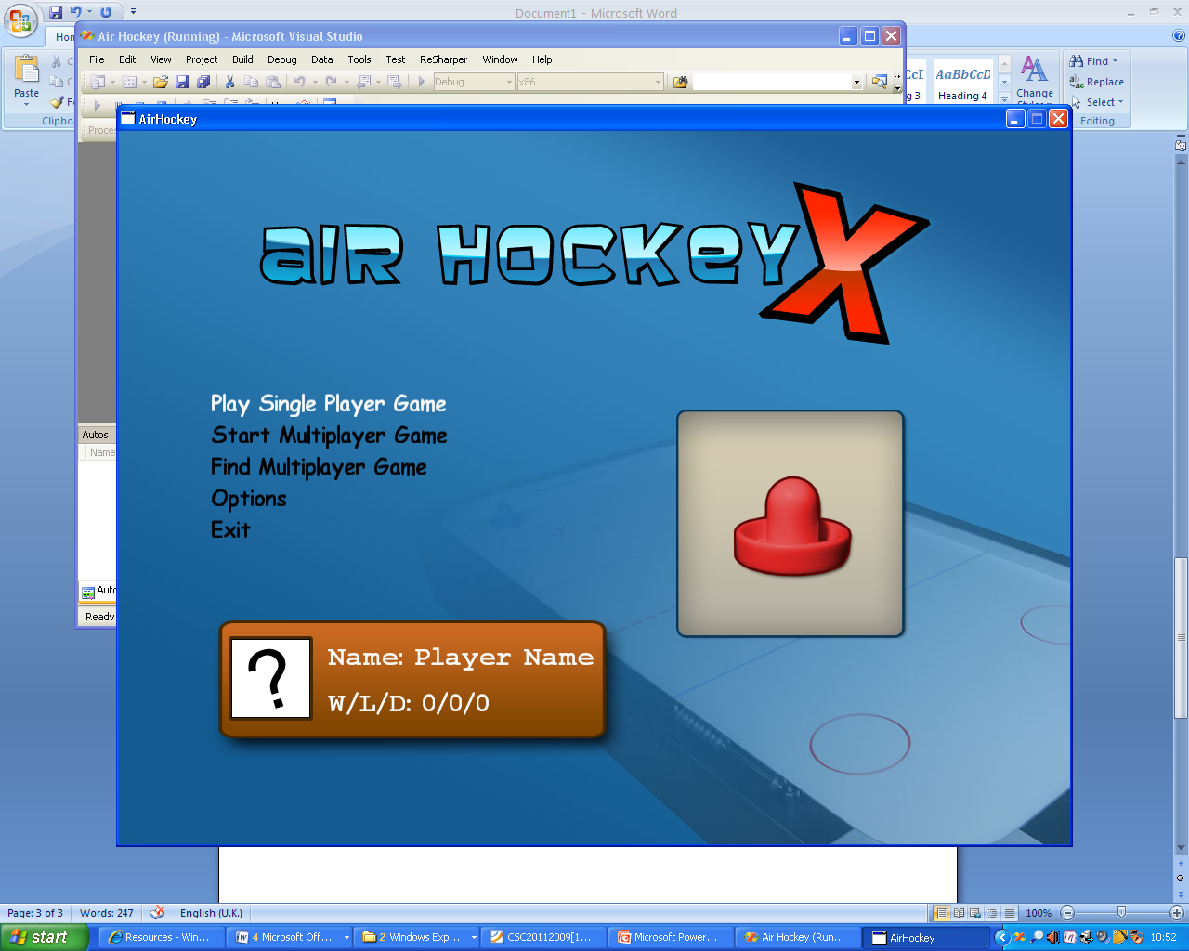

#### Result:

As shown, the program runs without error and creates a new profile for the user which is displayed. This new profile is also written to disk.